 |  |  | 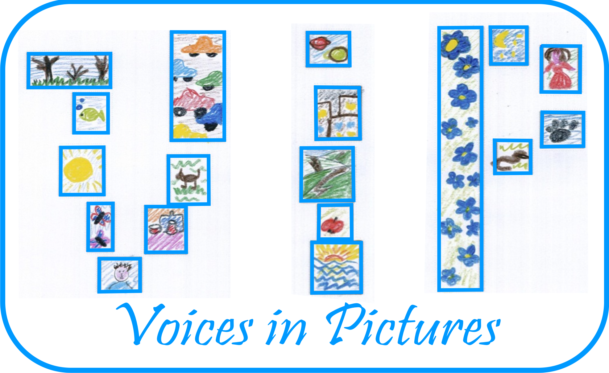

Activity Information
Voices in Pictures

Name of Activity | Beachdancing
Language(s) | English
Suggested Level | Any
Suggested Objectives | - To feel the differences between cultures;  - To be tolerant to different ways of entertainment;  - To involve everybody in speaking.
Procedure | - Splitting in small groups using vocabulary about dancing;  - A piece of picture with linedancers for every group to look at and get first emotions;  - Brainstorm ideas -where? why? what time? how long?  - To get other parts of the picture and compare ideas and discuss them with your partners;  - To create ideas for a similar crazy activity somewhere and somewhen;  - To make a poster-invitation to a crazy party and write 10 activities to entertain guests.
Other Comments | Crazy pictures, crazy activities, crazy texts keep talking.

Author and Country: Inese Skraustina Latvia Kusa Primary school Project: Voices in Pictures - 2013-1-DE2-GRU06-16272 1 This project is funded with support from the European Commission. The content reflects the views only of the authors, and the Commission cannot be held responsible for any use which may be made of the information contained therein.

