 |  |  | 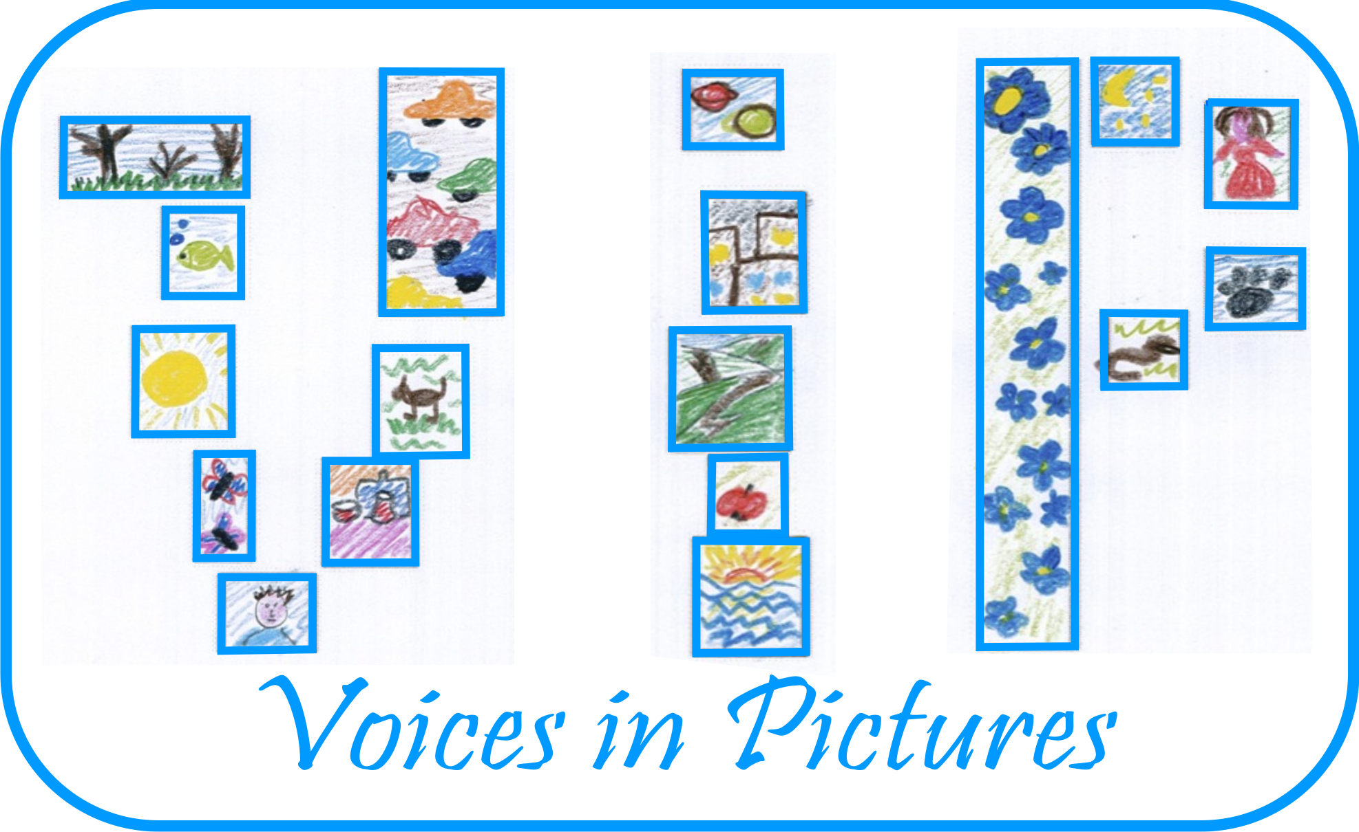

Activity Information
Voices in Pictures

Name of Activity | Cars FR
Language(s) | English
Suggested Level | Elementary
Suggested Objectives | - to encourage adults feel free in their imagination world;  - to share experiences about different ways of travelling.
Procedure | - Splitting in small groups using flashcards;  - Questionnaire about cars in every group;  - Sharing experience about cars changing groups (jigsaw activity);  - Compare answers and looking at the original photo find out whose story is more similar?  - Try to imagine you are sitting in one of these cars and thinking of a journey to … (which place, why, what to do/see there?) write a story of 120 words.
Other Comments | Really fascinating!

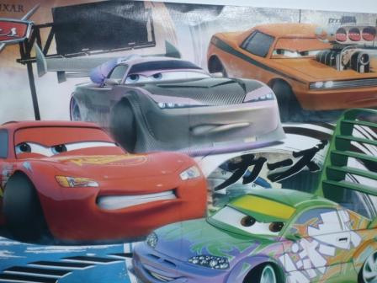

Author and Country: Inese Skraustina, Latvia Kusa Primary school Project: Voices in Pictures - 2013-1-DE2-GRU06-16272 1 This project is funded with support from the European Commission. The content reflects the views only of the authors, and the Commission cannot be held responsible for any use which may be made of the information contained therein.

