 |  |  | 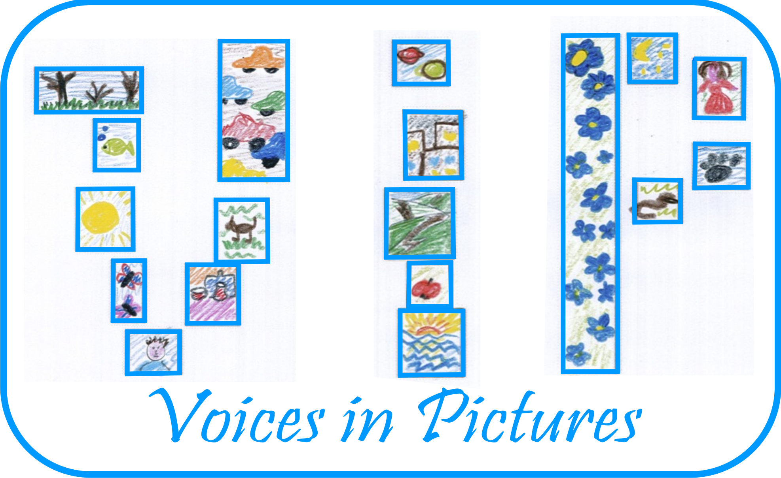

Activity Information
Voices in Pictures

Name of Activity | THE CENTENARIAN EUROPEANS
Language(s) | Any
Suggested Level | B1, B2, C1, C2
Suggested Objectives | - Competence: talk about your centenarian relatives, describe their past habits, compare their lives in the past with other Europeans'  - Intercultural competence: discuss and understand the reasons behind the differences. Identify national stereotypes and discard them  - Linguistic competence: use of past tenses, speculate  - Target skills: work in teams, debate, research (do a survey), write a report
Procedure | Show picture  Guess what those hands used to do  Give a speech about your own ancestors  Do the survey  Write a report
Other Comments | This activity works better with a multicultural group

Author and Country: Escuela Oficial de Idiomas de Gijón. Spain Project: Voices in Pictures - 2013-1-DE2-GRU06-16272 1 This project is funded with support from the European Commission. The content reflects the views only of the authors, and the Commission cannot be held responsible for any use which may be made of the information contained therein.

