Activity Information
Voices in Pictures

Name of Activity | Christmas Markets
Language(s) | English and all
Suggested Level | From A1-B1
Suggested Objectives | - Improve the vocabulary related to Christmas  - Improve speaking and writing skills  - Review vocabulary related to the family  - Review numbers  - Getting to know Bavarian Christmas traditions  - Cultural awareness of similarities and differences between Christmas traditions in learners ‘country and in Bavaria
Procedure | Activity 1 - Shopping at Munich Christmas Market  - The teacher gives a set of pictures to learners (group of 3 or 4)  - Learners have a look at the pictures and select articles they would like to buy as presents for Christmas for a given list of persons  - They give a reason for their choice of each present  Activity 2 – Dialogue – Pair work  - One learner is playing the role of the merchant. He/she can choose what he/she would like to sell.  - The other is the customer.  - They play the dialogue.  - They change the role and play the dialogue again.  Activity 3 – With my money I can buy …..  - The teacher asks learners to calculate what they can buy with the money of each purse.  - Collection of some answers on a board.  - Note: the currency can be changed. The prices should/could be adapted to the ones in the own country.  Activity 4 – About Christmas in Bavaria  - Learners watch the video clip (https://www.youtube.com/watch?v=mkeb5SHg4fo)  - They answer the questions (multiple choice)  - They comment similarities and differences between Christmas in Bavaria and in their country. They report about own traditions/family traditions.  Activity 5 - A Christmas letter to your friend in Bavaria  - Learners write a Christmas letter to a fictive friend in Bavaria.  - They have to give some specific information.
Other Comments | You will find these pictures and more on the project website of “Voices in Pictures”:  www.voicesinpictures.eu

Activity 1 – Shopping at Munich Christmas Market

- Have a look at the pictures and select articles you would like to buy as presents for Christmas for:
- Your mother ……………………………………………
- Your father ……………………………………………
- Your sister ……………………………………………
- Your brother ……………………………………………
- Your grandparents ……………………………………………
- Your wife/husband ……………………………………………
- Your daughter ……………………………………………
- Your son ……………………………………………
- Your aunt ……………………………………………
- Your uncle ……………………………………………
- Your cousin ……………………………………………
- Your boyfriend/girlfriend ……………………………………………
- Your best friend ……………………………………………
- You ……………………………………………
- Give reasons for your choice of presents
Example: For my grandma, I would buy some gloves to warm her hands in winter.
……………………………………………………………………………………………….……………………………………………………………………………………………….
……………………………………………………………………………………………….
……………………………………………………………………………………………….
……………………………………………………………………………………………….
……………………………………………………………………………………………….
……………………………………………………………………………………………….
……………………………………………………………………………………………….
……………………………………………………………………………………………….
……………………………………………………………………………………………….
……………………………………………………………………………………………….
……………………………………………………………………………………………….
……………………………………………………………………………………………….
……………………………………………………………………………………………….

Activity 2 – Role play – Pair work

One of you is the merchant selling some articles at the Christmas market. You can choose what you would like to sell.
Your partner is the customer.
Play the dialogue.

Change the role and play the dialogue again.

Activity 3 - With my money I can buy….

- Here are some purses with money. What can you buy with the money of each purse?

Example:

26,80 €
With 26,80 € I can buy

2 Christmas tree glass ornaments
(2,50 € each) 5 €

1 gingerbread heart 10 €

3 marmalade (2,10 € each) 6,30 €

Total 21,30 €
Rest 5,50 €


32,40 €
With 32,40 € I can buy


125,60 €
With 125,60 € I can buy

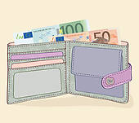
With 173,20 € I can buy

173,20 €

(http://www.fotosearch.de/clip-art/geldb%C3%B6rse.html)

Activity 4 - About Christmas in Bavaria

Watch the video clip on YouTube

https://www.youtube.com/watch?v=mkeb5SHg4fo

- Multiple choice exercise:

- Bavaria is in Poland
Austria
Germany

- Advent time starts 2 weeks before Christmas
4 Sundays before Christmas
On the 1st of December

- In the Advent calendar children find Chocolate
Apples
Toys
- Bavarian people drink hot wine In the church
At Christmas market
At Easter

- People decorate their Christmas tree with Apples
Bells
Wax figures

- The presents are brought by Santa Claus
The Christkind
Father Christmas

- Discuss the following points in small groups. Take notes and report to the class.

In the video senior learners are speaking about Christmas traditions in Bavaria

- What traditions are similar to the ones in your country?
- What didn´t you know?
- What is quite different from your own traditions?
- How important is Christmas in your family?
- Do you decorate your house and a Christmas tree?
- What do you usually eat at Christmas Eve?

Activity 5 - A Christmas letter to your friend in Bavaria

Write a letter to a fictive Bavarian friend (e.g. Gerda Hauser or Hans Muster).

Tell her/him: what you are going to do for Christmas
with whom you are spending Christmas Eve
what you intend to buy as presents for your family
if you are going to travel at that time of the year.

Ask her/him what she/he intends to do during the winter holiday season.


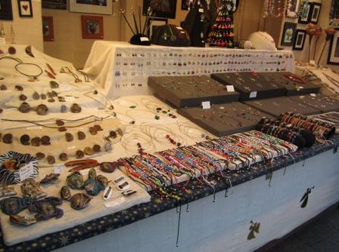   | 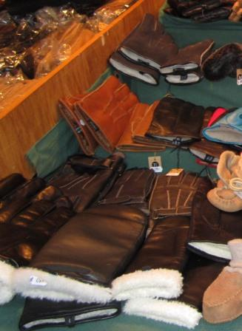
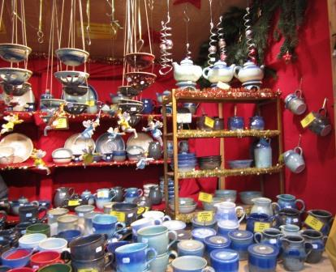 | 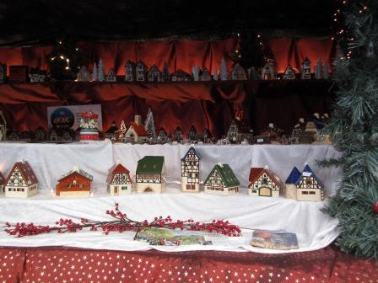
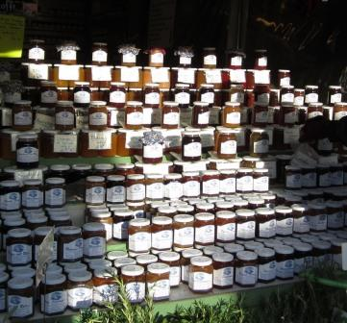 | 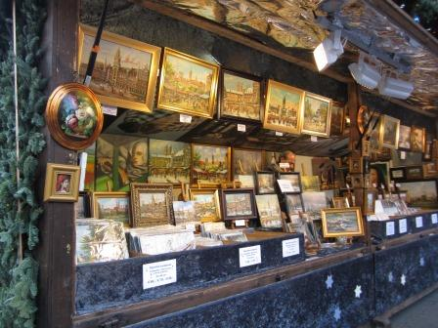
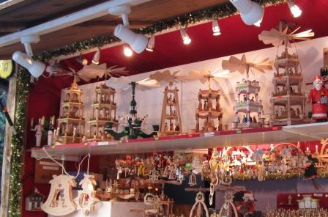 | 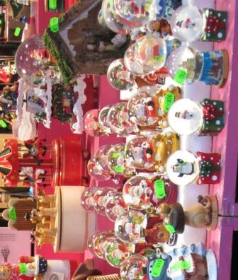
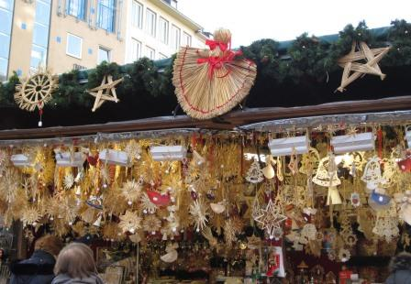 | 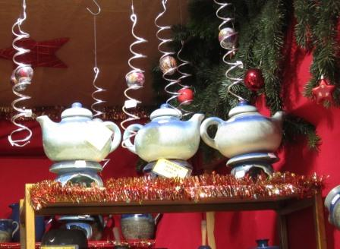
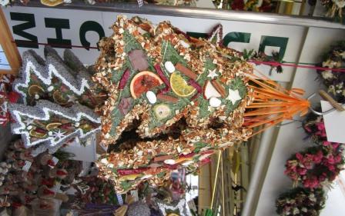 | 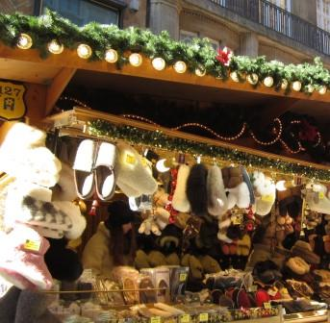
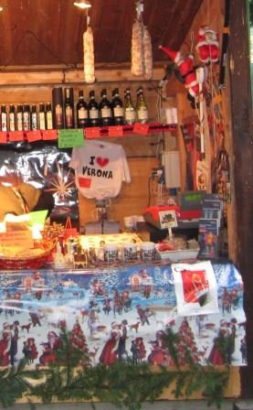 | 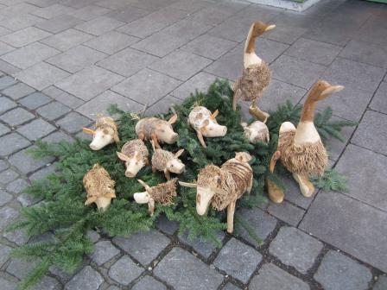
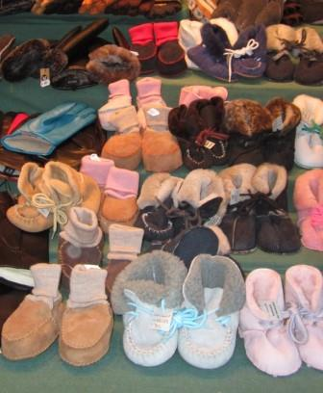 | 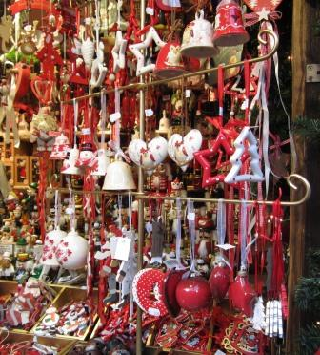
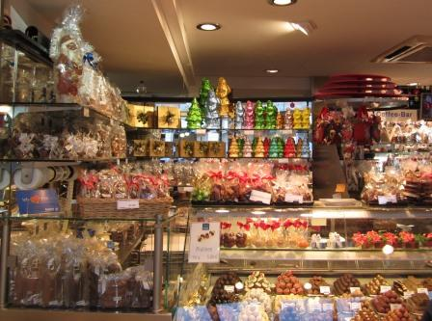 | 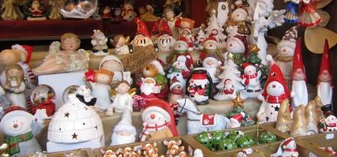
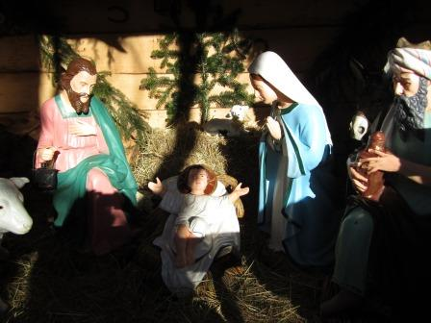 | 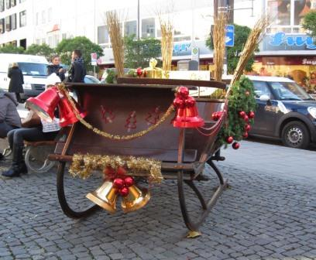
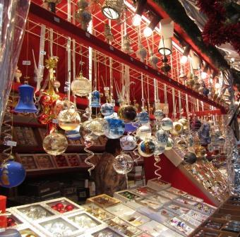 | 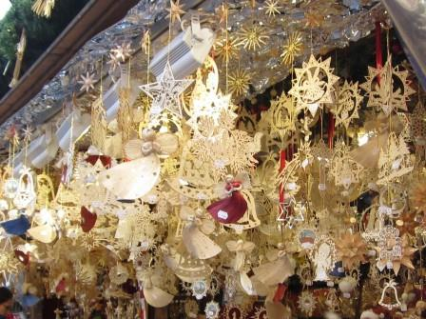
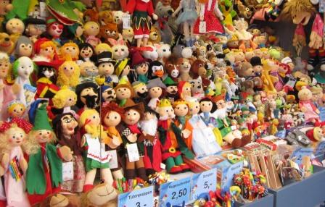 | 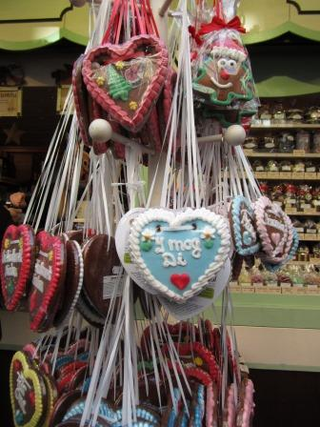
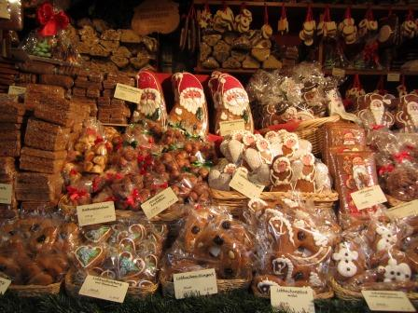 | 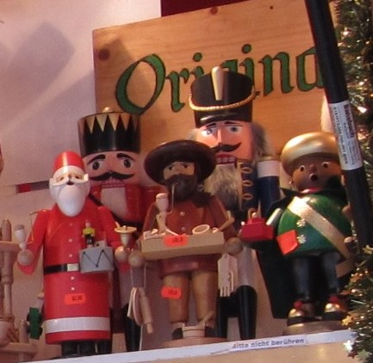

Vocabulary

Baby shoes
China ornaments
Chocolate
Christmas clay figures
Christmas decoration
Christmas manger
Christmas sleigh
Christmas tree glass ornaments
Christmas straw stars
Christmas wooden ornaments
Finger puppets
Gingerbread heart
Gingerbread sweets
Gloves
Jewels
Marmalade
Natural ornaments
Paintings
Pieces of pottery
Small houses
Small wooden towers with candles
Snow globes
Teapot
Warm slippers
Wine and cheese
Wooden animals
Wooden figures-nutcracker

