 |  |  | 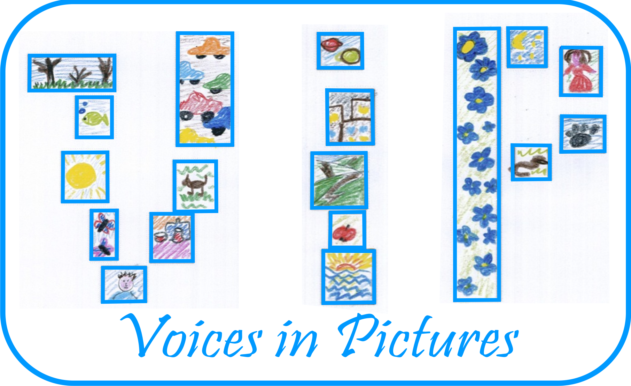

Activity Information
Voices in Pictures

Name of Activity | KLARA –a cat which likes reading
Language(s) | English
Suggested Level | Any
Suggested Objectives | - To encourage adults for reading to get more experience and self-confidence;  - To study other cultures and literature, way of life;  - Speaking for fluency.
Procedure | - Everybody gets a picture with Klara to look at it for 2 minutes and think about own way of reading habits;  - There are two circles-one in the middle –everyday readers and the other around -Sunday readers;  - The middle circle starts speaking face to face to the other circle about 1 minute, then next person and continue to get back the first one, change roles-the other circle is speaking now;  - Choose one mate you remember the best and tell about him/her;  - At the end you can make a summarize of different reading habits.
Other Comments | The question is How often does Klara sit in front of books? Does she get anything for Reading?

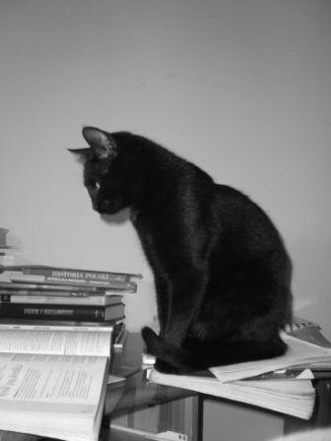

Author and Country: Inese Skraustina Latvia Kusa Primary school Project: Voices in Pictures - 2013-1-DE2-GRU06-16272 1 This project is funded with support from the European Commission. The content reflects the views only of the authors, and the Commission cannot be held responsible for any use which may be made of the information contained therein.

