 |  |  | 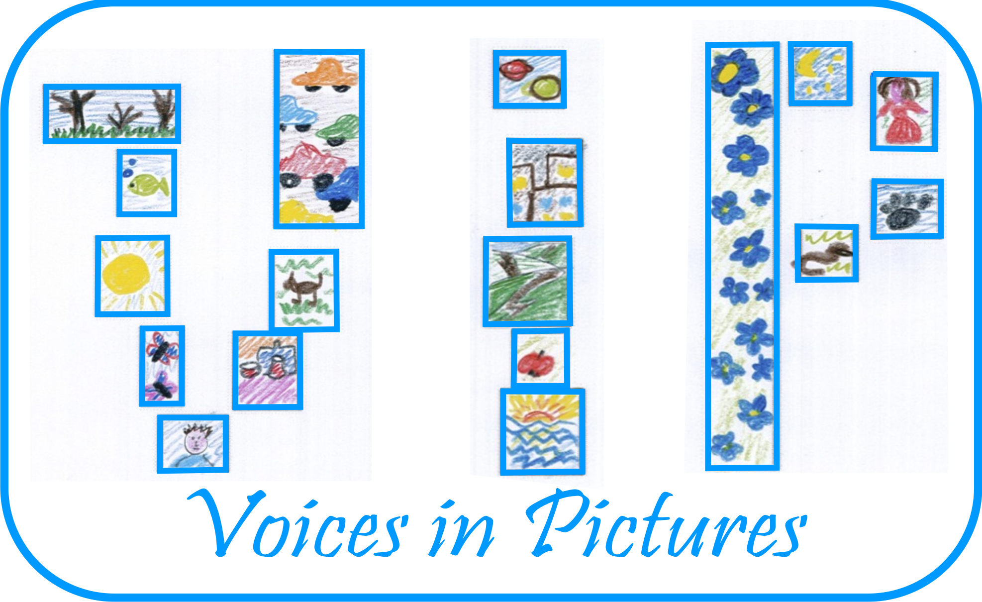

Activity Information
Voices in Pictures

Name of Activity | Modern ABC of Pictures
Language(s) | Any
Suggested Level
Suggested Objectives | - To create a modern ABC book.  - To discuss the current actualities.  - To learn presentation skills.
Procedure | - Acquaintance with the contest announced by UNESCO Latvian National Committee “Create an alphabet book”. Within the contest Latvian residents are invited to create a modern ABC book following the model of G. F. Stender’s “ABC of Pictures” - the first illustrated primer in Latvian (1787). Calligraphic letters, short instructions concerning an actual topics and illustrations are to be included in the book. Examination of Stender’s “ABC of Pictures”.  - In a period of 2 weeks participants prepare an explanation of at least one letter, including a calligraphic letter, an actual instruction, a wise saying and an illustration.  - During the lesson participants present their letters. A great variety of manners can be seen in the performances. Discussion about current issues leads to a conclusion – core values do not change.  - All works are included in an exhibition “Modern ABC book” in a hall of Kusa Primary school in April of 2014.  - An alphabet of songs is collectively sung on 21st of April 2014, during a celebration of Easter.  - Created material is scanned digitally and stored to be used in the work with the pupils in subsequent activities.
Other Comments | Latvian pupils’ created ABC book can be seen digitally www.darini.lv

Kusas pamatskola, Madonas novads, Latvija/ Latvia/Ilona Saare Project: Voices in Pictures - 2013-1-DE2-GRU06-16272 1 This project is funded with support from the European Commission. The content reflects the views only of the authors, and the Commission cannot be held responsible for any use which may be made of the information contained therein.

