 |  |  | 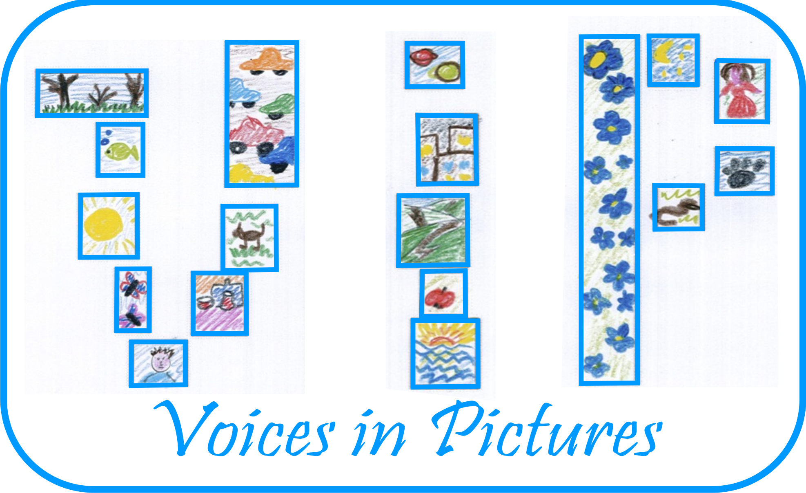

Activity Information
Voices in Pictures

Name of Activity | Find the book
Language(s) | any
Suggested Level | Elementary to Intermediate
Suggested Objectives | to elicit/teach about various library sections/book  types through image matching and categorizing in A  sTUDENT-led interactive activity in a public library  to activate language for asking for help and  directions and language for speculation in the  follow-up activity  to activate alphabetising skills
Author & Country | Mark Hevesi, Wales
Other Comments
  Context of the lesson sections in a library/different (mainly picture-
  based) book types
  Materials used pictures taken of site maps and books in the cardiff
  central library
  comments this activity is not meant to be comprehensive
  about library sections/book types as the main
  focus is on (finding AND SPECULATING ABOUT)
  pictures/photographs in books
  the implicit secondary aim of the activity is to make ss
  (re)discover the joys of browsing printed books as
  opposed to images on the internet/google
STAGE/TIME | AIM | PROCEDURE | INTERACTION
warm-up  15 mins. | to raise Ss interest and to demonstrate the main activity in a similar categorizing (picture-matching) task | tell Ss T is very interested in sharks and would like to find a book with photos of sharks in it; however all of the librarians are very busy so she/he can't ask - what should the T do?  ask Ss to brainstorm for what sections (> elicit) can be found in libraries, write Ss answers on BB  put Ss in groups of 3-4 and give  them the main section map of Cardiff Library (explain that these categories can vary in different libraries) - Ss to cross out the categories that have been mentioned (on BB) | T ↔ Ss  Ss ↔ Ss  (in groups)
lead-in activity (categorising)  15 mins. | to activate Ss' knowledge on book types/categories and prepare them for the main activity | Ss are given pictures of book covers (> elicit) and pictures of sections in the Cardiff Library - explain these books have been misplaced and they as "librarians" have to "put" the books back in the right sections (one category will have 3 matching books!) | Ss ↔ Ss  (in groups)
main activity (categorising and speaking)  15 mins. (instructions)  20 mins. (transport)  70 mins. (activity) | to activate language for asking for help and directions, and skills for alphabetising  to consolidate Ss' knowledge on book types | Ss are given an envelope with 4 book covers in them, pictures of the level maps (2-4) of the Cardiff Library and a 50 pence coin (to be opened in the library only!)  SS are told that when they are led to the library, they will have to locate these books in the relevant sections of the, first trying to guess which section the partical book may belong to (thus finding the right level)  once they agree on the section, they have to go to that level and ask a librarian to confirm they found the right section/they are on the right level > note: Ss are not allowed to ask the librarian to help find the book for them at this point!  Ss are encouraged to try and find the book first (spreading out individually to save time) without further help by alphabetising (> elicit the technique using the book covers from the first activity: by author or by title)  if the section is too large for them to cover or they can't locate the book (after 10-15 minutes), they can ask a librarian to show them where it is  when they have found the book, they have to look at and follow the instruction at the back of the cover image they had been given (they have to take a picture of a given page with their mobile phone)  they can return to the school when they have found all four covers and followed the instructions (so ideally, have four pictures on their mobile phone) | Ss ↔ Ss  (in groups)
follow-up speaking  20-25 mins. | to ask for feedback on the activity and activate language for speculation (it/they may be...; it/they can/could be...; I think it's/they're; maybe it's/they're etc.) | Ss are asked to give feedback on the activity  they are told that though it may not seem so, these pictures are related and weren't chosen randomly, and they have to find out the connection between them (elicit language for speculation on BB)  Ss are then asked to show the other groups the pictures they took (on a projector) and tell them how they think they are related  in the end, Ss are told there wasn't any connection at all - they have (hopefully  successfully ) demonstrated the powers of free association | T ↔ Ss  Ss ↔ Ss  (in groups)
follow-up project | to further Ss' interest in visiting libraries/reading | Ss are asked to find out about sections in their local library (list) | Ss

Activity Template Author and Country: Mark Hevesi, Wales Project: Voices in Pictures - 2013-1-DE2-GRU06-16272 1 This project is funded with support from the European Commission. The content reflects the views only of the authors, and the Commission cannot be held responsible for any use which may be made of the information contained therein.

