 |  |  | 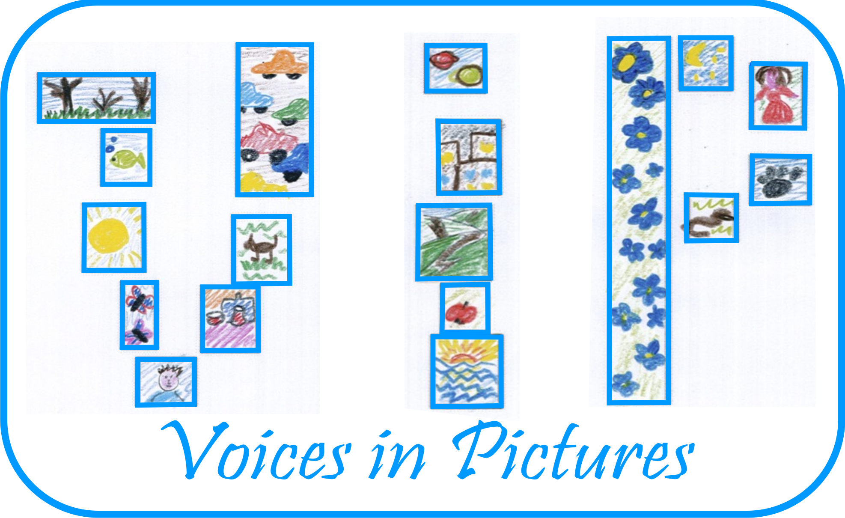

Activity Information
Voices in Pictures

Name of Activity | ‘SHOW AND TELL’
Language(s) | Any
Suggested Level | Elementary/Pre-intermediate
Suggested Objectives | Students:  - practice describing objects and defining their functions  - recycle/expand their vocabulary of everyday objects
Procedure | - Students are asked to take pictures of details of about 10 different everyday objects with their mobile phones/digital cameras and bring the pictures (printed out or stored on phones/cameras) to class. Pictures should be consciously made difficult to interpret (can be blurry, show objects from unusual angles, etc. The objects can be a plug, a socket, a pencil, a light bulb, a computer mouse, a lanyard, a cup, etc.)  - Teacher elicits/suggests the language to describe and define things and puts a selection of relevant phrases on the board.  It’s something which you use to…  It’s a kind of /a type of…  It helps you (do sth)  People use it to …  You write on it/you make music with it/you write with it.  You can find it in ...  It looks (a bit) like a …  When it’s new it looks like …,  It can be/it’s usually black or white. (…)  It’s similar to/like … ,but …  It’s flat/round/square/spiky/smooth/fuzzy …  It’s made of glass/wood, etc.  You can find it in every …  - Teacher tells students he/she is going to show them a picture of a detail of an object that they know very well. He/she shows them a ‘close up’ picture of an edge of a whiteboard and describes the object: It is flat. You write and draw on it. You can find it in every classroom. Students guess what he/she is describing.  - Teacher puts students into pairs. In pairs students take turns in describing everyday objects of their choice to one another (also showing pictures of the objects that students themselves took prior to the lesson) and guessing what these objects are. Students are encouraged to use as many ‘describing’ phrases as possible. Teacher monitors the activity.  - A development of the game could be an all-class game of describing things: students work in teams of two or three. Every group has to describe an everyday object of their choice using ‘describing’ phrases (see examples above). The team that comes up with the most detailed description/uses the highest number of ‘describing’ phrases wins!
Other Comments | This activity has been designed for foreign language classes, but it could also work as a game in other contexts.

Author and Country: Kat Ekiert, WE Bridge, Wales Project: Voices in Pictures - 2013-1-DE2-GRU06-16272 1 This project is funded with support from the European Commission. The content reflects the views only of the authors, and the Commission cannot be held responsible for any use which may be made of the information contained therein.

