 |  |  | 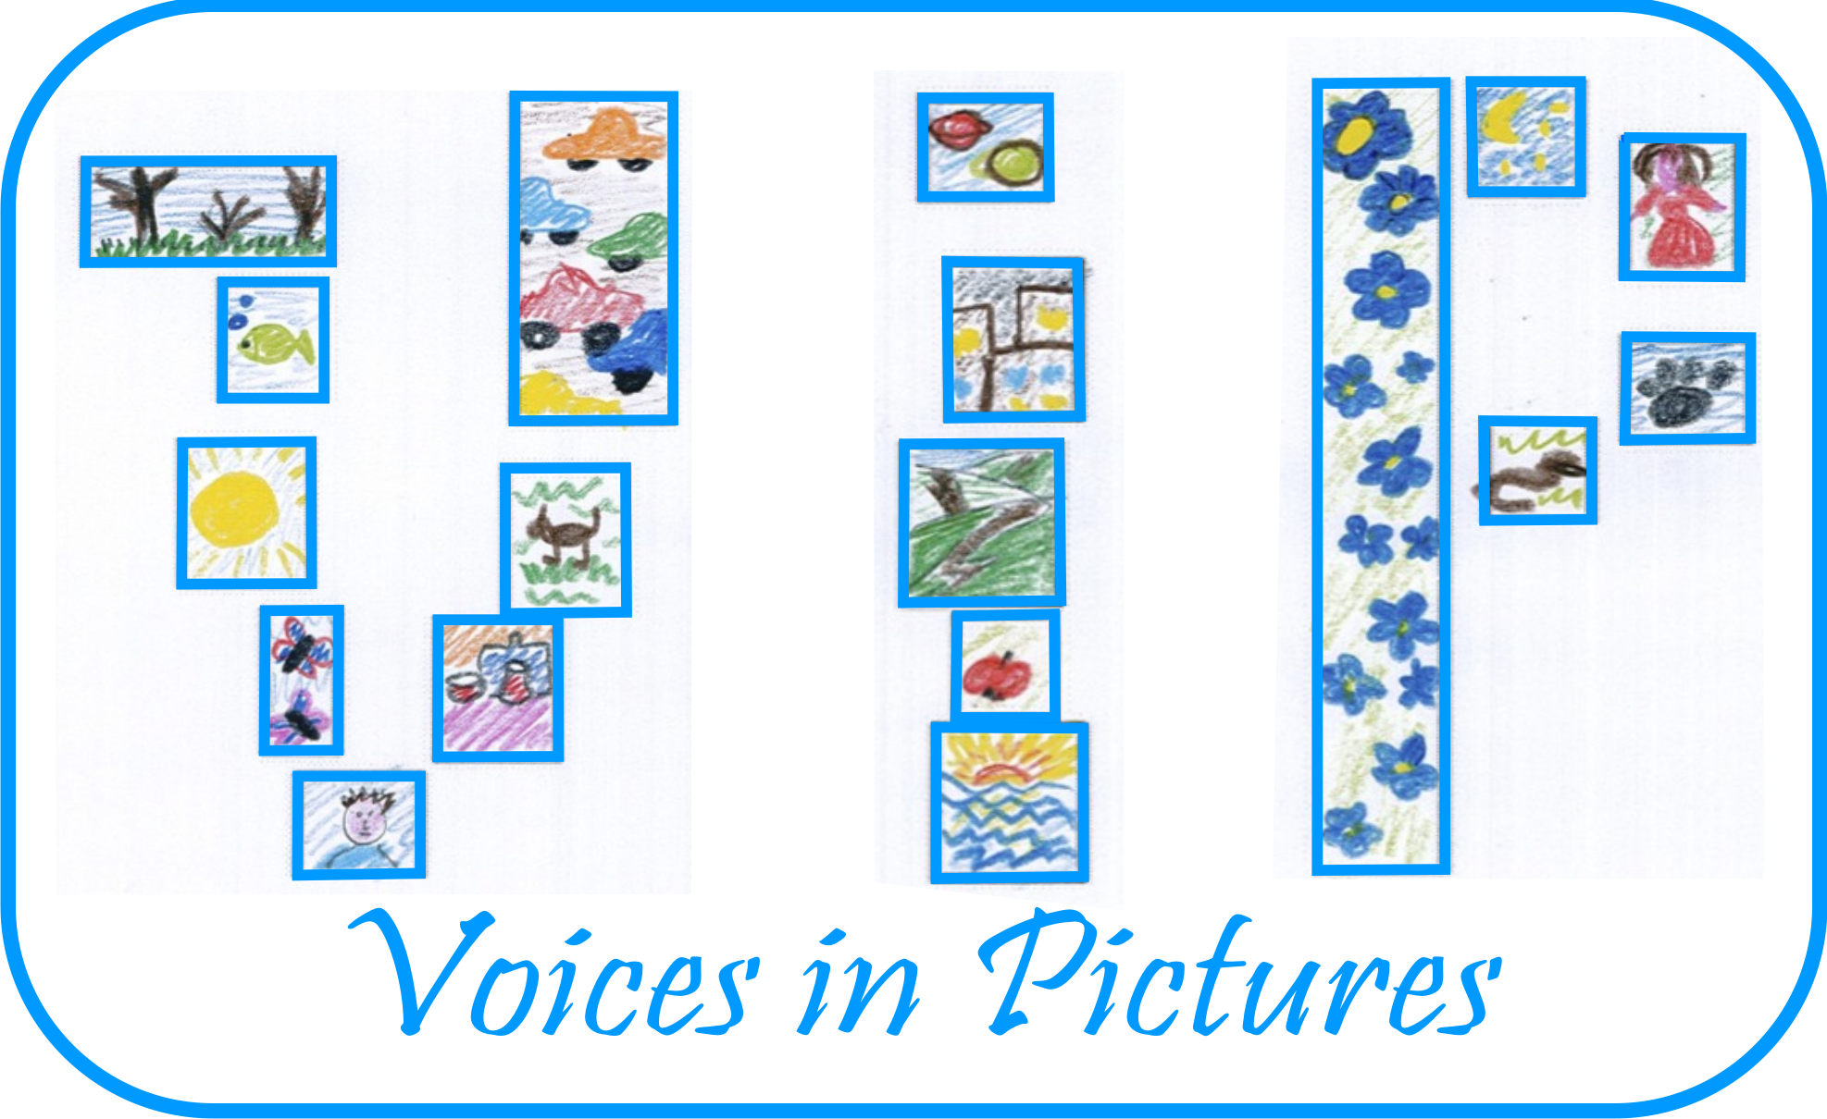

Activity Information
Voices in Pictures

Name of Activity | Siesta –sleeping under the blue sky next to goods.
Language(s) | English
Suggested Level | Any
Suggested Objectives | - To study other cultures and different ways of life;  - To get experience about street markets and the kitchen in other countries;
Procedure | - Pair work or group work (splitting using memory cards with phrases or word groups);  - The whole picture is cut like a puzzle and groups have to put it back;  - Looking at the picture groups complete sentences using phrases for discussion;  - Every pair or group create their own story about street markets in Latvia (what’s similar, what’s different);  - Every pair or group compare written texts and make a presentation for tourists.
Other Comments | It could be exciting to put the whole picture waiting for results.

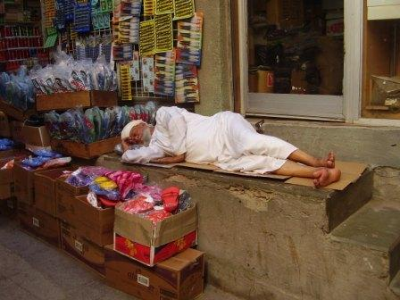

Author and Country: Inese Skraustina Latvia Kusa Primary school Project: Voices in Pictures - 2013-1-DE2-GRU06-16272 1 This project is funded with support from the European Commission. The content reflects the views only of the authors, and the Commission cannot be held responsible for any use which may be made of the information contained therein.

