 |  |  | 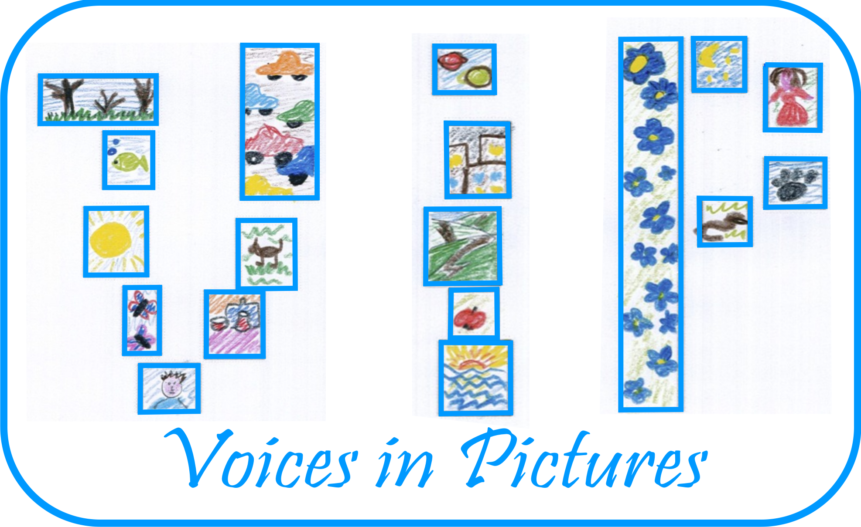

Activity Information
Voices in Pictures

Name of Activity | Markets
Language(s) | English (but can be adapted to use in any language)
Suggested Level | A2- B2
Suggested Objectives | to discuss and give opinions on different types of markets and to expand vocabulary connected with food
Author & Country | Georgeta Bradatan, Wales, UK
Other Comments | MaMaterials used: Photographs of different markets, PowerPoint presentation  re
Procedure | Stage | Aim | Time and interaction | Procedure
 | Lead-in / warm up discussion (slide 2) | To introduce the context of the lesson and to activate students' existing knowledge | 5 minutes  S – S | In pairs, students focus on the first slide of the PowerPoint presentation and are asked to discuss questions. Feedback with whole class.
 | Preparing for speaking (3) | To activate vocabulary connected with food | 5 minutes  S-S | Before showing photo T may organise a short contest 'how many words connected with vegetables/fruit can you write in a minute?' Elicit on board. Preteach more vocabulary if necessary.  Describe picture and answer questions in pairs. Feedback with whole class.
 | Speaking task (slide 4) | To practise vocabulary connected with food | 5 minutes  S-S | Ss discuss question in pairs and share with class
 | Speaking task (slide 5) | To using functional language of persuasion | 5 minutes  Ss-Ss | In groups Ss answer question on slide. Groups share results with whole class.
 | Speaking (slide 6) | To consolidate vocabulary and use functional language of prediction, supposition | 15 minutes  Ss-Ss | In groups Ss describe picture and imagine a story for the man in the picture. Ss share their story with the whole class.
 | Speaking (slide 7) | To encourage critical thinking and to further consolidate vocabulary on markets | 10 minutes  S-S | In pairs Ss discuss question on slide 6.  Divide class into 2 groups: Ss in favour of shopping in markets and Ss in favour of shopping in supermarkets. Organise a short debate between the 2 teams.
 | Speaking (slide 8) | To practise vocabulary and functional language from lesson | 10 minutes  S-S | Ss prepare dialogue in pairs and then act out in front of the class.
 | Homework | To consolidate language | N/A | Choose a photo from slide 9- 12 and describe.

Activity Template Author and Country: Georgeta Bradatan, WE Bridge International, Wales Project: Voices in Pictures - 2013-1-DE2-GRU06-16272 1 This project is funded with support from the European Commission. The content reflects the views only of the authors, and the Commission cannot be held responsible for any use which may be made of the information contained therein.

